Woodlands learning overview: 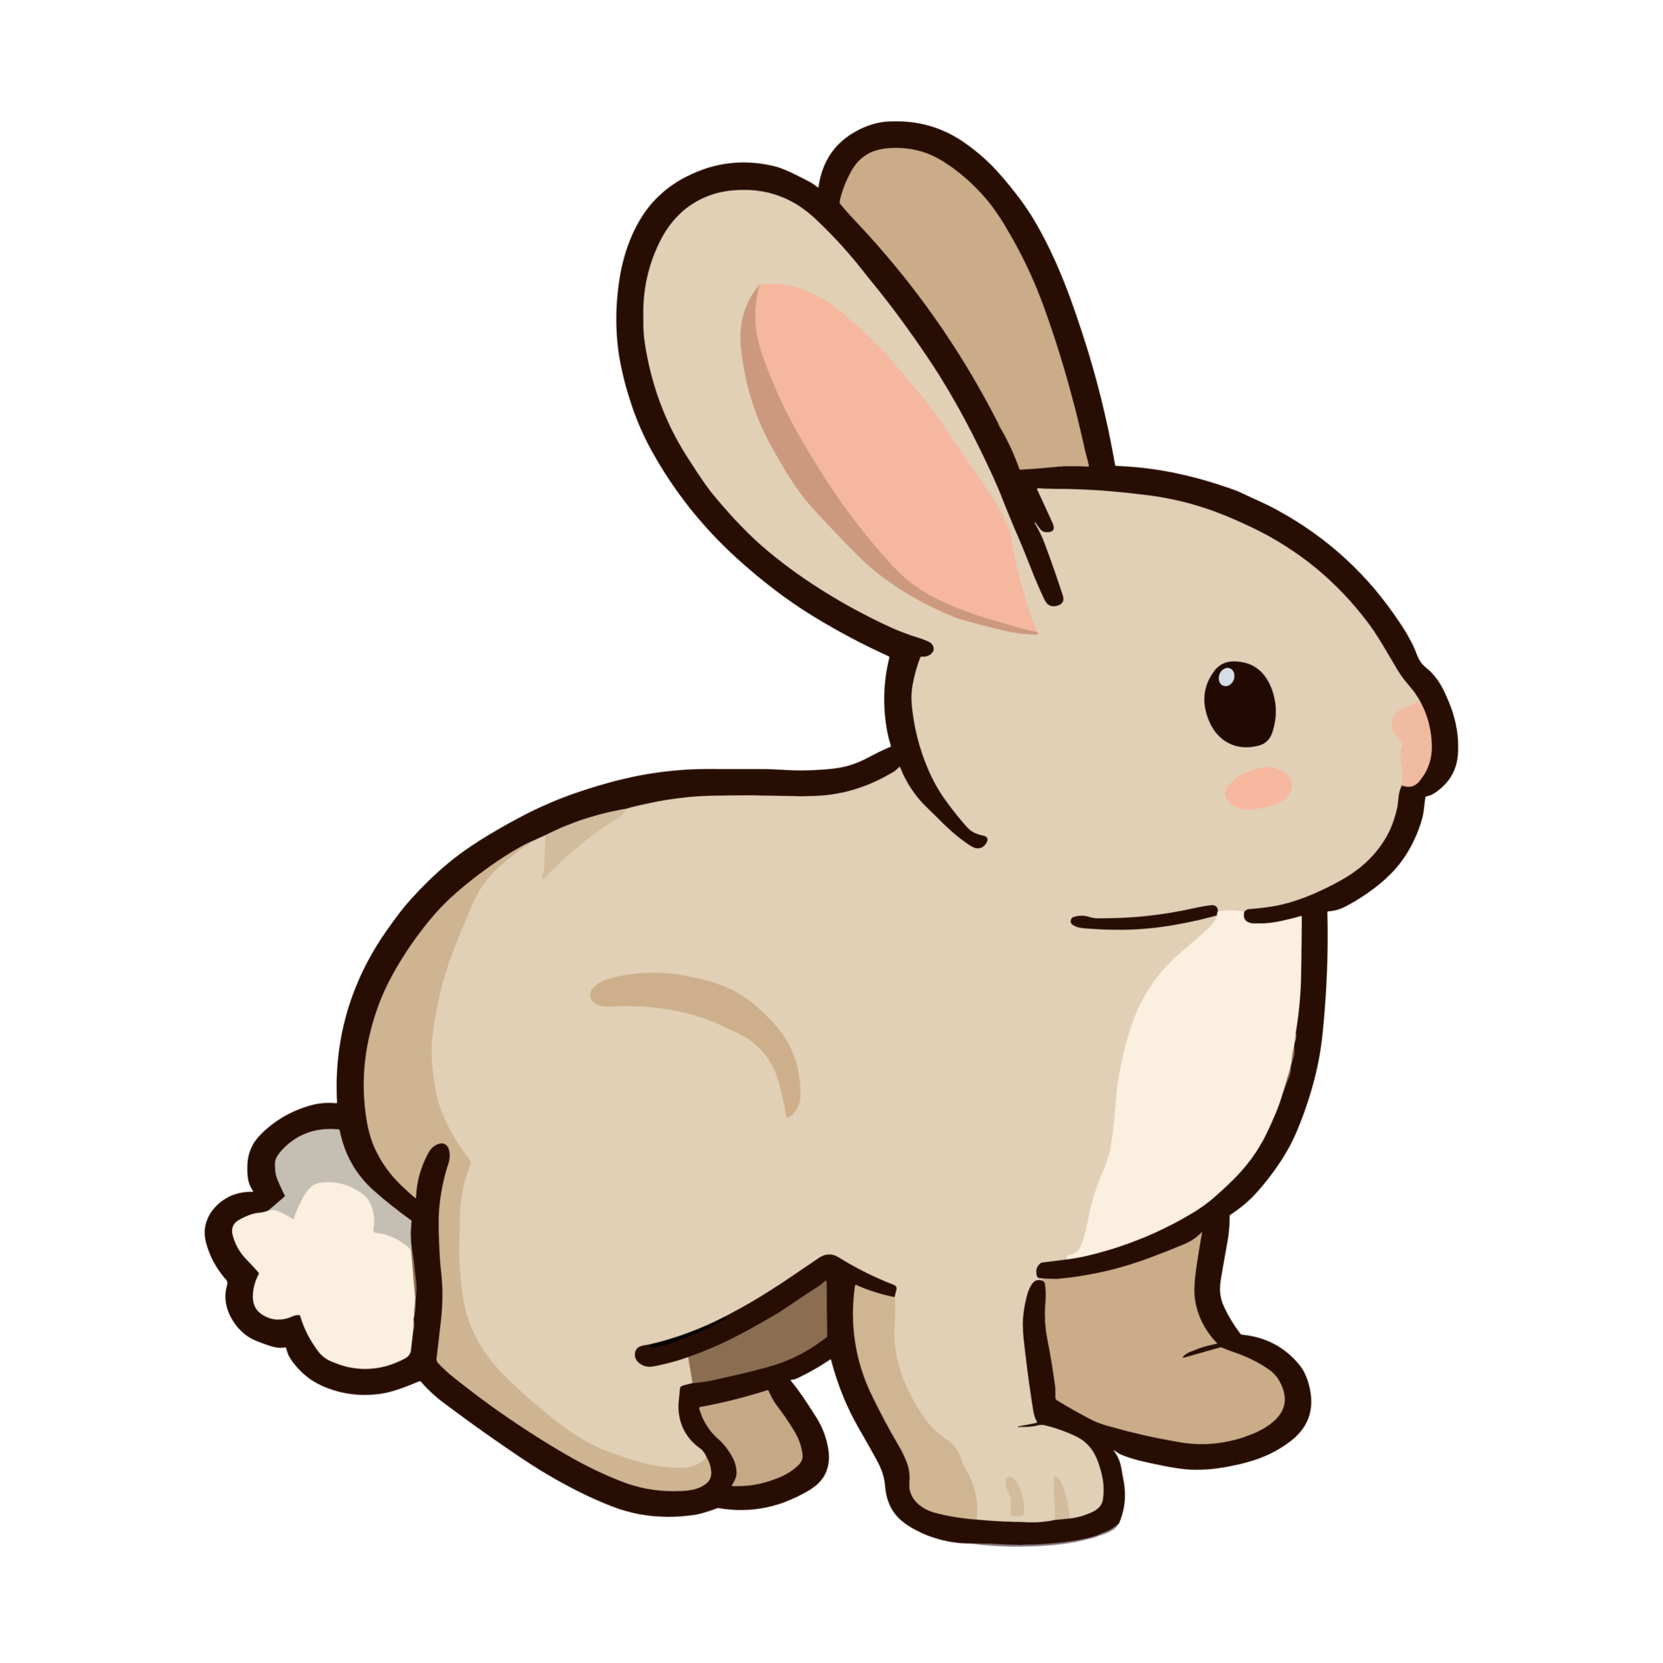
My independence
This half term, Woodlands will be cooking in our kitchen. We will be discussing basic health and safety and food hygiene. Learners will be able to choose appropriate cutlery and continue to practice using them.

Learners can access the dressing up area to practice independence.
My play and leisure
In my play and leisure we will be developing our tolerance levels, turn taking and confidence when immersed in play.
We will be participating in Activity games that can quickly develop into free play such as outdoor playground games and small world/role play in the classroom.
Spring 2

Welcome back! If you have any questions or concerns, please do not hesitate to get in touch via DOJO or speak to one of our dedicated members of staff.
Miss Molloy & Miss Patel 

Mathematics
In mathematics we will be continuing to work on estimating quantities for example we will be diluting water with juice. In our cooking sessions we will be weighing and sharing the ingredients. Through hands on activities, we will be practicing our counting to 50 and exploring numbers.

World about us
This term we will be learning about different seasons. Learners will identify the changes in our outdoor environment including visiting the outdoor classroom to explore Spring. Learners will use supporting evidence to confirm seasonal changes.

English
Upon arrival into Woodlands learners find and write their names. We will be practicing using spacing between words that reflects the size of the letters.
This half term we will be looking at Spring. Learners will use simple key words or sentences to label pictures. We will continue to focus on our letter formation and word finding.
Learners read daily and practice phonics and tricky words!

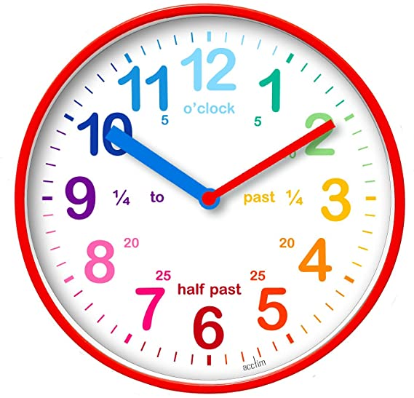 We hav
My communication
In my communication we will continue to express ourselves through communicating using storytelling, facial expression and role playing.
We will share experiences, ideas and feelings with each other during dedicated circle time.
We will continue to practice engaging and sharing ideas with each other.

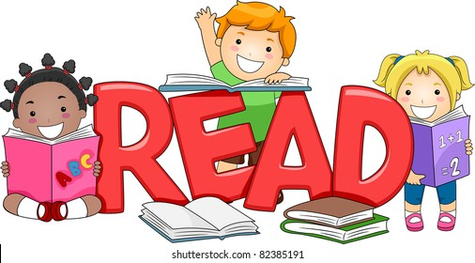
Reading books need to be brought back in to school every day. Make sure you are reading a book at home at least 3 times per week.
We will be visiting the outdoor classroom every Thursday afternoon
My Sensory
This half term through engaging sensory activities we are exploring the five senses – touch, sound, smell, taste and sight.
In addition to this we are developing our early knowledge of colour and colour mixing.

