Roebuck EYFS Home Learning Autumn 1

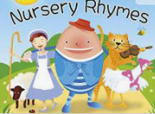Our topic this season is all about me. Please try the following activities at home with your child across Autumn Term. You can share your home learning with us on Class Dojo.

Practise writing your name.

Support and encourage your child to write their name at home.

How have you changed?

With your child, look at your child’s baby photos. Ask them how have they changed? What can they do now that they couldn’t do as a baby?

Nursery rhymes

Nursery rhymes are so important for children’s communication and language development. Talk to your child about their favourite nursery rhyme. Sing nursery rhymes together. Listen to nursery rhymes on youtube.

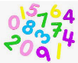

Titch / Once there were Giants

Read the story with your child or listen to the story on youtube. Ask your child what happened in the story. Ask your child who lives in your house and who is in your family.

Sound walk

Go on a local walk; listen and discuss the sounds you can hear.

Maths

Odd one out- Have a set of objects- Which was is the odd one out? It could be the odd one out because of colour, shape or size. Discuss this with your child.

Counting- sing number songs together, practise counting and recognising numbers to 20.

Dressing and helping at home

Encourage your child to dress and undress themselves including putting a coat on, zipping the coat up and fastening buttons. Encourage your child to help at home by tidying their room or helping with the dishes.